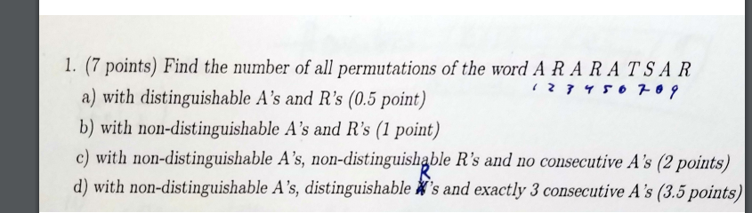

permutation排列，

distinguishable 有区别的，也就是说第一个A是紫色的A，第二个A是蓝色的A

9！

9！/4!3!

没有连续A

先放好RTS,A找一个放右边

A先看做两个

剩下的按顺序放，然后A有两种放法

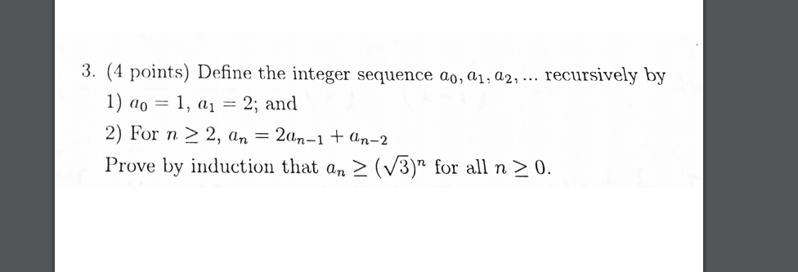

1)basic when a0=1 a1=2

then a2= 5>xx

2)assume for all k<=n, ak>=q^k

3) then ak+1=2ak+ak-1>=2\*q^k+q^(k-1)=2/q\*q^k+1+ 1/q^2

2q+1/q^2 >1

one>=8

x1+x2+x3+x4 =11

所有的方法就是不考虑范围解法

4 pick k from n people ,then pick a group leader

lhs firstly,pick k group member from n, because order doesn't matter, so it is

an+2-5an+1+6an=0

xN+2

a2x2-5a1x2+6a0x2=0

...

f(x)-a0-a1x-5x(f(x)-a0)+6x^2f(x)